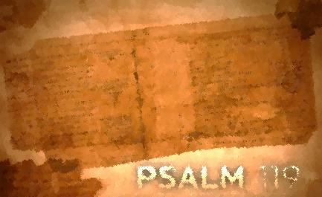
Psalm 119:97-112
Lesson Eight
Heavenly Wisdom/Psalm 119:97-104

In this section the psalmist begins with his love for God’s law and ends with his hate for every false way. In between he traces how he got there. His wisdom path includes meditation, putting into practice God’s word, and restraining himself from every evil way. Hebrew wisdom was not theoretical and speculative, being satisfied with knowledge. It was practical, based on revealed principles of right and wrong, to be lived out in daily life in the home and community. His comparison to others (enemies, teachers, and elders) is not a prideful assertion of superiority but a form of rejoicing in the Lord himself, whose wisdom is more direct and superior (v. 102). It is God’s word that is superior to everyone else’s. Join in tasting God’s word with the psalmist and experience its sweetness (only serving to cause us to hunger for more!).

Assignment:
Read Psalm 119:81-88; take time to listen, receive, and do.
1. What are the effects of God’s word in our lives?

2. What is the attitude of the psalmist toward God’s word?

3. What actions does the psalmist take or plan to take?

4. Which phrase or word stands out to you? Consider meditating on these phrases or words.

For each question, reflect on how the psalmist’s interaction with God’s word compares with yours. How would you answer each of these questions? Where do you see potential for growth? Is there one step that God is calling you to take right now to deepen your interaction with His word?

Write your prayer of response to God as a result of meditating on Psalm119: 97-104.

Not Losing the Way/Psalm 119:105-112

Perseverance is one of the practical ways that wisdom is worked out in our lives.
Notice how the psalmist’s joy and determination to please the Lord are much greater than the affliction with which he lives constantly. He continues to ask the Lord to teach him and to accept his sacrifices (worship). Remaining open to God is critical when affliction is a part of our lives. Running from or attacking the affliction might be our first response but the palmist has chosen a different way. That way is to walk down that lighted path that God’s word provides until the very end. Join the psalmist in walking down that path.

Assignment:
Read Psalm 119: 105-112; take time to listen, receive, and do.
1. What are the effects of God’s word in our lives?

2. What is the attitude of the Psalmist toward God’s word?

3. What actions does the psalmist take or plan to take?

4. What does the psalmist specifically ask God to do?

5. Which phrase or word stands out to you? Consider meditating on these phrases or words.

For each question, reflect on how the psalmist’s interaction with God’s word compares with yours. How would you answer each of these questions? Where do you see potential for growth? Is there one step that God is calling you to take right now to deepen your interaction with His word?

Write your prayer of response to God as a result of meditating on Psalm 119: 105-112.

