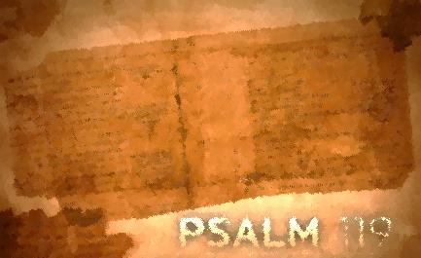
Psalm 119:49-64
Lesson Five
Steadying Words/Psalm 119:49-57

The other evening I thought I had forgotten my favorite hat at a sushi restaurant in Seattle. I’ve done it before. I get involved in the moment and neglect my old buddy that protects my thinning haired head from the damaging sunrays. The psalmist isn’t like me. In the midst of attack he remembers his Protector. He doesn’t get sidetracked with the moment, instead he remembers the steadying promises and name of the One (52, 55) who has not forgotten him (49). Join the psalmist and receive the comfort and reviving word of our Protector.

Assignment:
Read Psalm 119:49-57; take time to listen, receive, and do.

1. What are the effects of God’s word on the psalmist’s life? How does it impact him?

2. What actions does the psalmist take or plan to take?

3. What does the psalmist specifically ask God to do?

4. Which phrase or word stands out to you? Consider meditating on these phrases or words.

For each question, reflect on how the psalmist’s interaction with God’s word compares with yours. How would you answer each of these questions? Where do you see potential for growth? Is there one step that God is calling you to take right now to deepen your interaction with His word?

Write your prayer of response to God as a result of meditating on Psalm119:49-64.

With All My Heart/Psalm 119:57-64

For the psalmist, it is on God’s account that he loves the writings that reveal Him. He ends this stanza with the proclamation that the earth is full of Yahweh’s lovingkindness and begins it with announcing that the Lord is his portion. Everything in between expresses the outcome of responding to Yahweh’s merciful love. Join the psalmist as he expresses his love for the One who loves him.

Assignment:
Read Psalm 119:57-64; take time to listen, receive, and do.

1. What are the effects of God’s word? How does it impact him?

2. What actions does the psalmist take or plan to take?

3. What does the psalmist specifically ask God to do?

4. Which phrase or word stands out to you? Consider meditating on these phrases or words.

For each question, reflect on how the psalmist’s interaction with God’s word compares with yours. How would you answer each of these questions? Where do you see potential for growth? Is there one step that God is calling you to take right now to deepen your interaction with His word?

Write your prayer of response to God as a result of meditating on Psalm 119:57-64.

