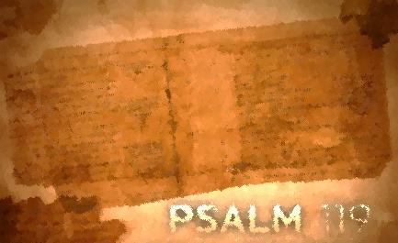
Psalm 119:33-48
Lesson Four
Teach Me/Psalm 119:33-40

Do you hear the psalmist’s urgent prayer requests? These appeals come out of the now familiar backdrop of his internal struggles (verse 37) expressed, this time, by his desire to withhold his gaze from vanity (anything that is unsubstantial, unreal, worthless, either materially or morally) as well as the external pressure (verse 39) of those who are reproaching him. Most often the Hebrew word for “vanity” is associated with idols (Jeremiah 18:15), the most worthless deceptions of all. Most likely the psalmist recognizes his tendency to run to that which is false (perhaps dishonest gain, verse 36) during times of external pressures. In contrast, he now prays that God would teach him and give him understanding. In a day of many addictive idols this stanza pleads for the life giving and freeing alternative.

Assignment:
Read Psalm 119:33-40; take time to listen, receive, and do.

1. What is the attitude of the psalmist toward God’s word? What are his feelings regarding God’s word?

2. What actions does the psalmist take or plan to take?

3. What does the psalmist specifically ask God to do?

4. Which phrase or word stands out to you? Consider meditating on these phrases or words.

For each question, reflect on how the psalmist’s interaction with God’s word compares with yours. How would you answer each of these questions? Where do you see potential for growth? Is there one step that God is calling you to take right now to deepen your interaction with His word?

Write your prayer of response to God as a result of meditating on Psalm119:33-40.

Words for Others/Psalm 119:41-48

Jesus said that a good tree cannot bear bad fruit, and a bad tree cannot bear good fruit. His point: you can tell the nature of someone by the “fruit” of their lives. James applied this to words when he wonders how praising God and cursing man can come from the same mouth. The cursing reveals the true nature of the one speaking, coming from a “salt spring” not a “fresh spring”. Similarly, the psalmist recognizes his desperate need to speak “the word of truth” (42, 43, and 46). Just as God’s merciful salvation has been appropriated though God’s promises he now desires that reality to shape what comes out of his mouth.

Assignment:
Read Psalm 119:41-48; take time to listen, receive, and do.

1. What are the effects of God’s word? How does it impact him?

2. What actions does the psalmist take or plan to take?

3. What does the psalmist specifically ask God to do?

4. Which phrase or word stands out to you? Consider meditating on these phrases or words.

For each question, reflect on how the psalmist’s interaction with God’s word compares with yours. How would you answer each of these questions? Where do you see potential for growth? Is there one step that God is calling you to take right now to deepen your interaction with His word?

Write your prayer of response to God as a result of meditating on Psalm 119:41-48

