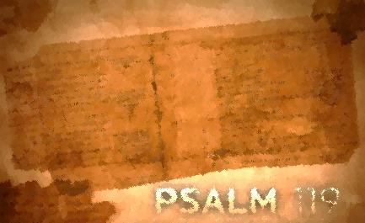
Psalm 119:1-16
Lesson Two
An Undivided Heart/Psalm 119:1-8

We often face crossroads, those places where there are multiple choices that include paths of integrity and paths of duplicity. The psalmist writes about those who seek God with all their heart and as a result walk carefully and thoughtfully according to all that He has commanded. Sounds like a pretty big order until he gets to the last line of this stanza, “Do not forsake me utterly.” Those are the words of someone prone to straying and knows it. Not only is confession good for the soul, but the first step in admitting that we can’t walk on those paths of righteousness on our own. We are desperate and need God’s deliverance, revival, and guidance. Join the psalmist as he expresses his heart’s desire, admitting that he is a learner (a disciple).

Assignment:
Read Psalm 119:1-8; take time to listen, receive, and do.

1. What is the attitude of the psalmist toward God’s word? What are his feelings regarding God’s word?

2. What commitments does the psalmist make?

3. What actions does the psalmist take or plan to take?

4. What does the psalmist specifically ask God to do?

5. Which phrase or word stands out to you? Consider meditating on these phrases or words.

For each question, reflect on how the psalmist’s interaction with God’s word compares with yours. How would you answer each of these questions? Where do you see potential for growth? Is there one step that God is calling you to take right now to deepen your interaction with His word?

Write your prayer of response to God as a result of meditating on Psalm 119:1-8.

Stored Treasure/Psalm 119:9-16

Usually we hide stuff because we are afraid someone might take it. However, in this stanza the psalmist treasures (hides) God’s word in his heart that he might not sin. God’s word germinates and sends its roots deep into our soul (like soil!). The young man (the psalmist) isn’t preaching to anyone but he is praying, pointing God’s finger at himself. Again he knows that he can wander. So, he proclaims that he is teachable and ready to receive this treasure with thanks. Join the psalmist as he receives God’s word for His intended purpose.

Assignment:
Read Psalm 119:9-16; take time to listen, receive, and do.

1. What is the attitude of the psalmist toward God’s word? What are his feelings regarding God’s word?

2. What are the effects of God’s word in our lives? How does it impact us?

3. What commitments does the psalmist make?

4. What actions does the psalmist take or plan to take?

5. What does the psalmist specifically ask God to do?

6. Which phrase or word stands out to you? Consider meditating on these phrases or words.

For each question, reflect on how the psalmist’s interaction with God’s word compares with yours. How would you answer each of these questions? Where do you see potential for growth? Is there one step that God is calling you to take right now to deepen your interaction with His word?

Write your prayer of response to God as a result of meditating on Psalm 119:9-16.

