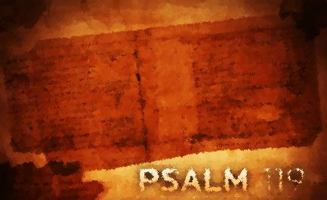
Overview
Lesson One

Psalm 119 is an acrostic psalm¹ which means that each line in each section begins with one of the 22 letters of the alphabet in order from aleph (the first Hebrew letter) to tav (the last Hebrew letter). This giant of a Psalm (176 verses) is an alphabet of prayers and reflections on the Word of God, giving each letter its turn to introduce eight successive verses on the Scriptures. For the Hebrews the style lends itself to memorization or hiding it in one’s heart. As you reflect on this psalm you will notice several themes that run throughout, intermingled with one another, not in any particular order. The praying poet is not concerned with sequence of thought but establishing a meditative mood with his circumstances and preoccupations as a stimulus for further prayer and reflection.

Like the unknown psalmist², our response to this psalm can be further prayer, meditation on God’s Word, and love for Yahweh. These will foster hiding His word in our hearts and delighting in His word, which in turn leads us to obeying His word, and allowing His word through the power of the Holy Spirit to shape, order, and enlighten our thinking, speaking, and acting.

Assignment:

1. Read Psalm 119 (yea, I know you’ve already read it…well do it again and again.) Mark or notice the qualities ascribed to the Scriptures. Make a list and meditate on these qualities. Like the psalmist, consider your life’s circumstances and/or preoccupations. How is Father God challenging you to consider how He desires to use His word in your life at this time?

¹ This form of Hebrew poetry is also found in Psalms 9-10 (taken together), 25, 34, 37, 111, 112, and 145.
² The options appear to be David, Ezra, or a group of compilers.

2. What is the attitude of the psalmist toward God’s word? What are his feelings regarding God’s word?

3. What commitments does the psalmist make?

4. What actions does the psalmist take or plan to take?

5. What does the psalmist specifically ask God to do?

For each questions 2-3, reflect on how the psalmist’s interaction with God’s word compares with yours. How would you answer each of these questions? Where do you see potential for growth? Is there one step that God is calling you to take right now to deepen your interaction with His word?

