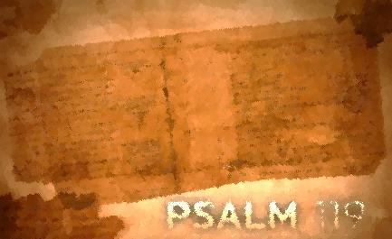
Psalm 119:145-160
Lesson Eleven
The Bigger Reality/Psalm 119:145-160

Notice the greater truth? Though the psalmist’s enemies are drawing near, the bigger reality is that the Lord is even closer. This relationship with God and His testimonies has been well established giving him confidence in his day of trouble. He doesn’t have that foxhole mentality of calling out to God only when in distress. The practice of waiting upon the Lord morning and evening has been long established, so much so, that when trouble comes he is already in a dependent, receiving position. While God could very well deliver him from his circumstance, His saving help comes in word form first and foremost. Can you receive the saving word of God with our psalmist?

Assignment:
Read Psalm 119:145-160; take time to listen, receive, and do.
1. What are the characteristics of God’s word?

2. What actions does the psalmist take or plan to take?

3. What does the psalmist specifically ask God to do?

4. Which phrase or word stands out to you? Consider meditating on these phrases or words.

For each question, reflect on how the psalmist’s interaction with God’s word compares with yours. How would you answer each of these questions? Where do you see potential for growth? Is there one step that God is calling you to take right now to deepen your interaction with His word?

Write your prayer of response to God as a result of meditating on Psalm119145-160.

Precious Life/Psalm 119:153-160

The psalmist’s life needs reviving. Three times he appeals for God’s refreshing touch according to His word, ordinances, and lovingkindness. Mingled with his life-fading desperation is the confidence in what God has promised. God’s covenantal love and mercy is his hope and his obedient response is the evidence of his faithfulness to the holy agreement. The psalmist places his life in God’s hands. He rests his case and waits for God’s action in His time and way. Can you call out to God and rest your case in the hands of your merciful and loving God?

Assignment:
Read Psalm 119:153-160; take time to listen, receive, and do.
1. How are God and His word described?

2. How does the psalmist speak of his life and situation?

3. What actions does the psalmist take or plan to take?

4. What does the psalmist specifically ask God to do?

5. Which phrase or word stands out to you? Consider meditating on these phrases or words.

For each question, reflect on how the psalmist’s interaction with God’s word compares with yours. How would you answer each of these questions? Where do you see potential for growth? Is there one step that God is calling you to take right now to deepen your interaction with His word?

Write your prayer of response to God as a result of meditating on Psalm 119:153-160.

