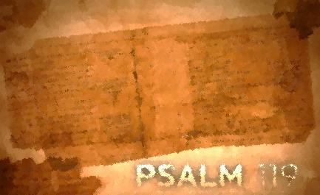
Psalm 119:129-144
Lesson Ten
The Light Shines in the Darkness/Psalm 119:129-136

Is this stanza ever timely? We live in a day when darkness feels like it is encroaching on every turn. We, too, echo the psalmist’s plea to be redeemed from the oppression of man. But let’s not neglect the rest of this “enlightening” stanza. Instead of letting the shadowy realities of those who do not keep God’s law overwhelm him, he once again runs to the light of God’s word. Instead of being sucked into the dark hole of oppression, he opens (unfolds) God’s word and lets Him shed light on his path, seeking redemption (God’s shining face) in God’s presence and wisdom. The psalmist can’t help but be heartbroken at the disregard for God’s law, but he is not derailed in his servanthood, learning God’s ways and obeying them. Join the psalmist as he walks in light.

Assignment:
Read Psalm 119: 129-136; take time to listen, receive, and do.
1. How is God’s word described? What are its characteristics?

2. What are the effects of God’s word in the psalmist’s life? How does it impact him?

3. What actions does the psalmist take or plan to take?

4. What does the psalmist specifically ask God to do?

5. Which phrase or word stands out to you? Consider meditating on these phrases or words.

For each question, reflect on how the psalmist’s interaction with God’s word compares with yours. How would you answer each of these questions? Where do you see potential for growth? Is there one step that God is calling you to take right now to deepen your interaction with His word?

Write your prayer of response to God as a result of meditating on Psalm119: 129-136.

Everlasting Righteousness/Psalm 119:137-144

Stability can be hard to come by when surrounded by instability. What’s interesting is that the psalmist’s zeal for God and His word increases as unrighteousness around him increases. Why, because he knows where his stability lies. Notice how he describes God and His word: righteous (the standard of right living and thinking), upright (without fault), faithful, and pure. The adjectives give strength to this stability: exceeding faithfulness, very pure, everlasting and forever righteousness. Do you hear what he is emphasizing? He has an anchor, a firm foundation, a sure way to follow because of the very nature and character of the One who has spoken authoritatively. In his anguish the psalmist holds on to faith in the Lord. Though he does not yet see the end of his present troubles, the psalmist knows his God’s character has been tested over and over again in redemptive history. He knows in whom he has put his trust. Therefore, he does not challenge the Lord’s integrity but prays humbly that he may “understand” so that he may be revived in his inner being. Need reviving? Seek to follow the psalmist’s path of faith.

Assignment:
Read Psalm 119:137-144; take time to listen, receive, and do.
1. How are God and His word described?

2. What are the effects of God’s word in our lives? How does it impact us?

3. how does the psalmist speak of his life and situation?

4. What actions does the psalmist take or plan to take?

5. What does the psalmist specifically ask God to do?

6. Which phrase or word stands out to you? Consider meditating on these phrases or words.

For each question, reflect on how the psalmist’s interaction with God’s word compares with yours. How would you answer each of these questions? Where do you see potential for growth? Is there one step that God is calling you to take right now to deepen your interaction with His word? Write your prayer of response to God as a result of meditating on Psalm 119: 137-144.

