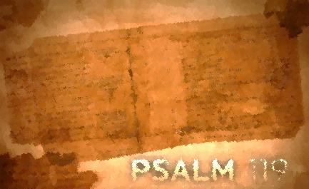
Psalm 119:113-128
Lesson Nine
No Renegade/Psalm 119:113-120

What a contrast between the wicked and the righteous. The presence of God is so real for the psalmist that he responds to his God in spirit and body. His life of obedience is lived in the presence of the living God. God is his hiding place and shield, his sustainer, and his upholder. Yet, he physically trembles (literally, his hair stands on end!) at God’s mighty revelation in His word. The wicked are not so; acting as if God does not see or care being double-minded, wondering from God’s word, and acting with deceitfulness. Join the psalmist as he continues down the lighted path which leads to the love of all that surrounds his awesome yet intimate Lord.

Assignment:
Read Psalm 119:113-120; take time to listen, receive, and do.
1. What are the effects of God’s word in the psalmist’s life?

2. What is the attitude of the psalmist toward God’s word?

3. What actions does the psalmist take or plan to take?

4. What does the Psalmist specifically ask God to do?

5. Which phrase or word stands out to you? Consider meditating on these phrases or words.

For each question, reflect on how the psalmist’s interaction with God’s word compares with yours. How would you answer each of these questions? Where do you see potential for growth? Is there one step that God is calling you to take right now to deepen your interaction with His word?

Write your prayer of response to God as a result of meditating on Psalm119: 97-104.
Pressure from the Godless/Psalm 119:121-128

We don’t hear the word “servant” too much anymore. As our self-oriented culture continues down its path of self-sufficiency, it’s little wonder. Not so for our psalmist. He is Yahweh’s servant, and his loyalty stands against all those that oppress him. As God’s servant he does justice and righteousness; he hopes, with endurance, for God’s salvation; he remains teachable; and he shows zeal for the honor of God and His laws and a hatred of an ungodly way of life. The logic of his loyal servanthood is that he becomes more devoted the more the pressure grows because the more the pressure grows the more he values God’s holy way. How about you? Can this be said of you? Why or why not?

Assignment:
Read Psalm 119:121-128; take time to listen, receive, and do.
1. What is the attitude of the Psalmist toward God’s word?

2. What actions does the psalmist take or plan to take?

4. What does the psalmist specifically ask God to do?

5. Which phrase or word stands out to you? Consider meditating on these phrases or words.

For each question, reflect on how the psalmist’s interaction with God’s word compares with yours. How would you answer each of these questions? Where do you see potential for growth? Is there one step that God is calling you to take right now to deepen your interaction with His word?

Write your prayer of response to God as a result of meditating on Psalm 119:121-128.

